Greg Heitman

Dr. Pulimood

CSC 415-01

25 March, 2016

Assignment 4: Open Source Software – Analysis and Design

Use Case Descriptions

*Adopting a fire hydrant (already an established part of system):*

1. The user opens the web application to view the map of Boston, Massachusetts and various hydrant icons.

2. He/she drags and manipulates the zoom of the map to search for an appropriate hydrant.

3. Upon finding a desired hydrant, the user clicks the marker to view whether it is currently owned or vacant.

4. If not already signed in, the user enters their identification credentials to log into their individual account. These credentials include an email address, password, and phone number.

5. After signing in, the user clicks on a hydrant and selects “Adopt!” to gain ownership of hydrant.

*Update or view information about fire hydrant condition / state:*

1. The user opens the web application and selects a specific hydrant on the map.

2. The user selects a new option named “Update/view status”

3. A table appears with information about the hydrant, including its location, name, and contact info of the current owner. To edit, a user selects the “Edit” button, modifies specific fields, and then selects “Submit changes” to save them.

4. A “Notes” section, which stores user-generated messages about the hydrant, can viewed. Users can select “Add note” to add a new update to the list about the current hydrant.

Design Class Diagram

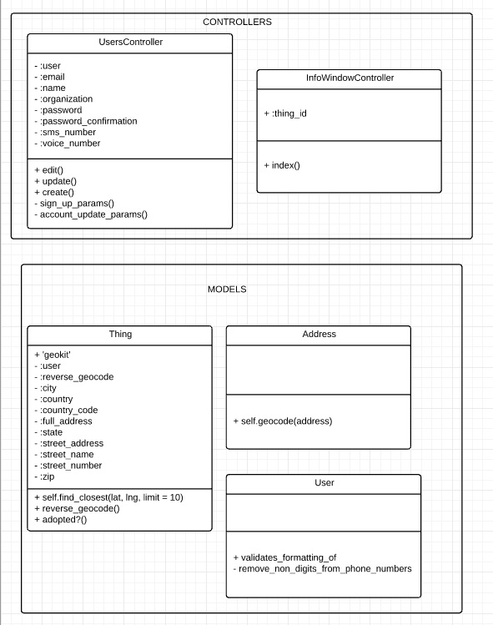

State Chart for System/Algorithms

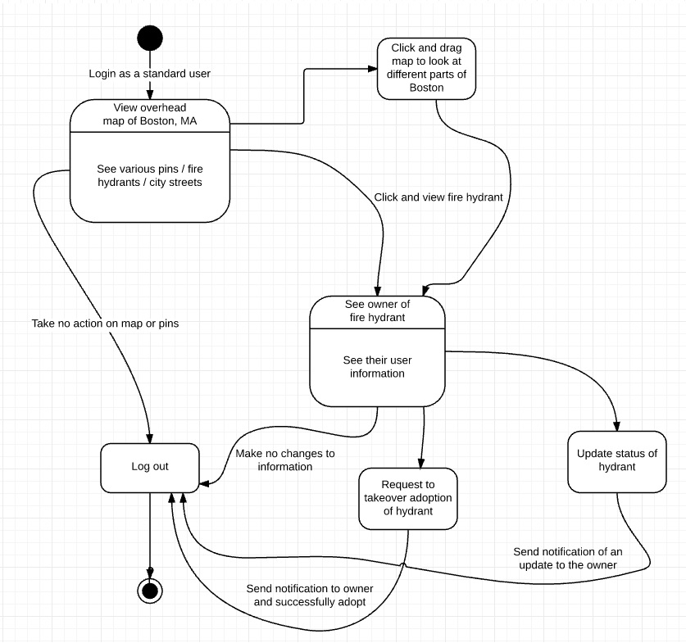

Test Case Design

In testing my contributions to the open source project, I will be using both unit and integration testing. I will use unit tests to determine whether the components like user information retrieval/storage and hydrant note updates. Then, I will use a top-down integration method to examine the cohesion of these processes together, with the inclusion of interface elements like a button to edit a note, add a note, or update the overall status of a fire hydrant. The gdb debugging tool will be valuable to use, as I can step through each individual line or block of code and testits functionality.

|  |  |  |  |
| --- | --- | --- | --- |
| **Functionality Tested** | **Inputs** | **Expected Output** | **Actual Output** |
| User information and credentials properly stored | Email, name, organization, home phone, mobile, password | These fields are saved with the users’ credentials correctly input |  |
| Viewing/updating hydrant status | Clicking on hydrant, clicking update button, accessing status of hydrant, changing status | Changes and updates to status are reflected |  |
| Viewing notes about hydrant status | Clicking chat log next to hydrant status, clicking “Edit” or “add note” button | Adds note with timelog to conversation about the hydrant’s ownership and status |  |
| Adopting a hydrant (already in use) | Scroll on map to hydrant, click hydrant, select “Adopt” on vacant hydrant or “request ownership” on taken | User is notified that they have adopted hydrant successfully or that they have reached out to current owner |  |